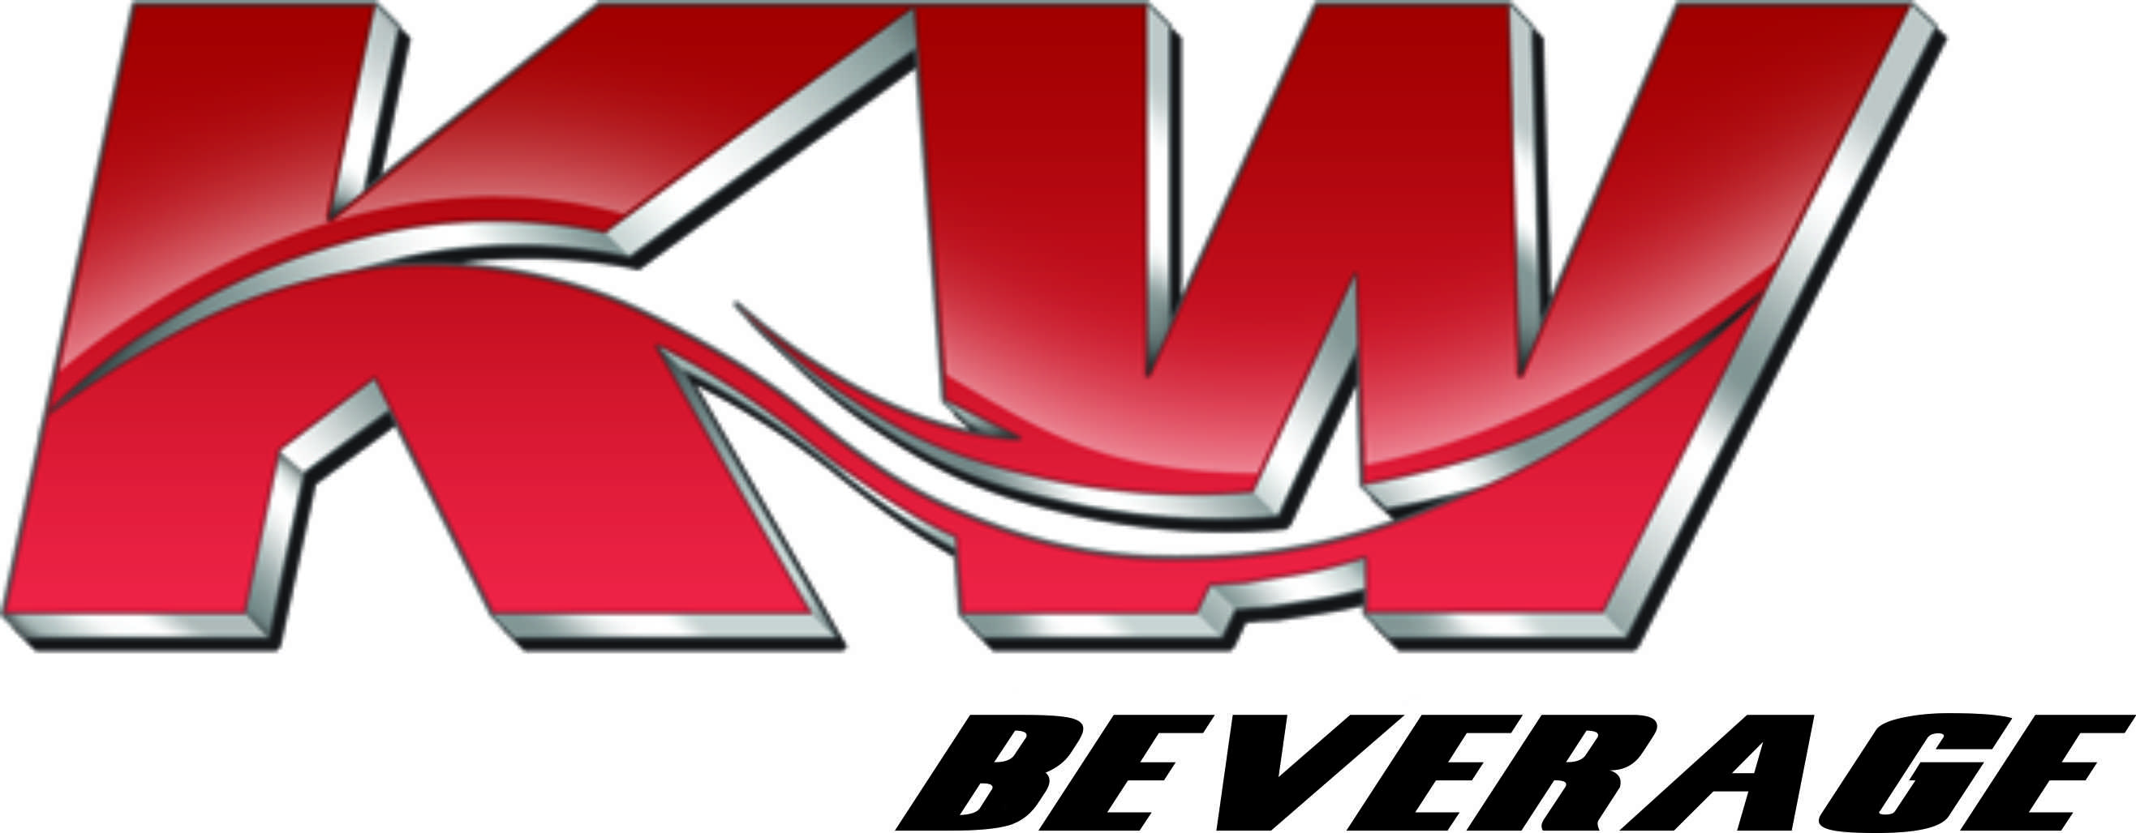
WAREHOUSE ORDER PICKER
JOB DESCRIPTION

Basic Purpose:
To follow the specific guidelines developed by KW Beverage concerning the warehouse order picking process for safe and effective delivery of all KW Beverage’s products. Reports directly to the 2nd Shift Warehouse Supervisor under direction from the Warehouse Manager.

Responsibilities:
- Responsible for picking and building orders to specifications through a Voice Directed Picking system.
- Must be knowledgeable in the use of RF Scanners with accuracy and error-free.
- Verifying the accuracy of the order being built.
- Must pick loads in an efficient and timely manner while maintaining production standards.
- Accountable for product damage and package integrity.
- Must keep work area clean and neat throughout the shift.

Expectations:
- Must be able to work second shift. Approximately 4:00pm until 02:30am Monday thru Friday or at a set time as your job requires.
- Must pass a drug test, back ground screening.
- Must be over 21 years of age.
- Valid SC state driver’s license.
- Able to operate a powered pallet jack.
- Complete 90 day probationary period.
- Always maintain a neatly groomed personal appearance and a fresh, wrinkle free uniform every day.
- All facial hair (beards, goatees and mustaches) must create an overall neat, polished and professional look.
- Must be to work on time, attend all meetings and training sessions daily.
- Must tolerate some long hours depending on the season, etc.
- Work as part of a team and help your teammates when necessary.
- Efficiently pick customer orders for shipment, ensuring that the correct number and type of product is loaded and shipped.
- Assemble various types of merchandise for shipment. Carry or transport orders to shipping locations or delivery platforms with material handling equipment.
- Must attend all safety classes before using lifts and handling products.
- Learn the Anheuser-Busch and other supplier beverage freshness code system and apply it to working the pick line.
- Must be able to read all product code dates.
- Must be willing to train new warehouse reps when asked.
- Must be safety conscious and strive to be accident free in all aspects of the position.
- Work to minimize damaging product while stacking packages on pallets.
- Making decisions as an individual for the betterment of the team is a must.
- Organized and detail orientated.
- Must be knowledgeable and comply with all company policies.
- Must perform any other duties requested by management.
- Must comply with attendance policy point system.

The following physical demands are required but not limited to:

Walking, Sitting, Lifting, Carrying, Pushing, Climbing, Stooping, Bending, Kneeling, Reaching, Pulling, Standing

_______________________________ ___________________________________
Warehouse Order Picker: #3016 Date
Michael J Davis
_______________________________ ___________________________________
Witness Date

Revised: 1/28/15

